56 + 57 a) Favelas Problems and Solutions
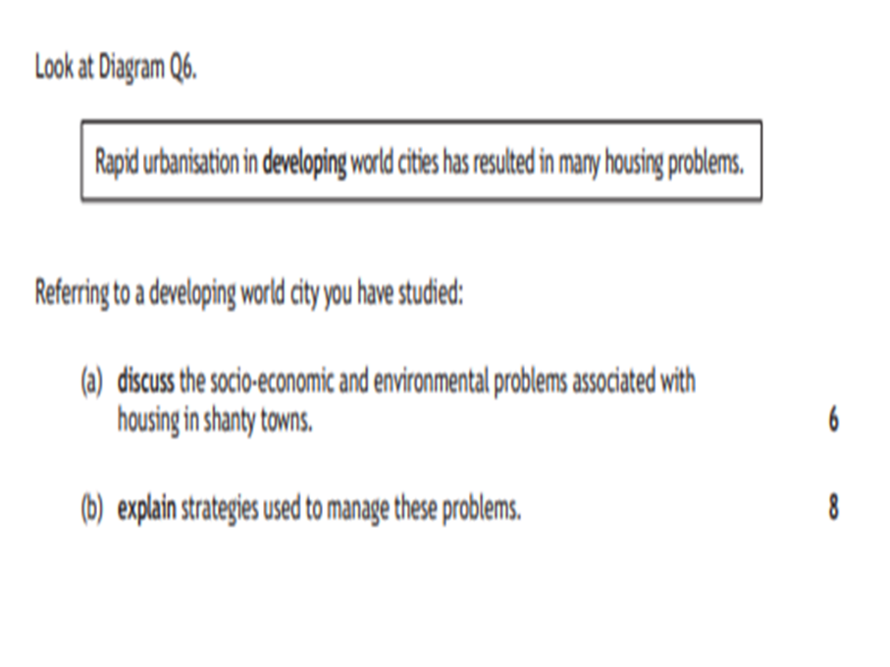

- In the favelas in Rio (linked to developing country), a lack of underground sewage means sewage running on streets (tick). This contributes to high levels of disease (tick). Illegal electricity connections can cause fires (tick). Due to lots of housing in a small area, it is very overcrowded (tick). Houses are built illegally with basic materials (tick). Built on steep land which means easy destruction from landslides (tick). Housing areas are often controlled by drug gangs leading to high crime rate (tick). High rates of unemployment, many people take small jobs such as street vendors (tick). = 8 marks out of 6.
- Self help schemes is where the Brazilian government have provided residents with the materials needed to build improve their homes and the favela residents do the work themselves (explain tick). Site and Service schemes, are when the local authority is in charge of building projects (explain tick) – the Favela Bairo Project (example tick) put £200 million aside and focused on replacing wooden houses and adding in vital services such as water supplies and underground sewage (explain tick). Barra Di Tijuca was a new suburb of Rio built to provide more housing for people and help overcrowding (explain tick). Morar Carioca was a program set up to urbanise all favelas for the 2016 Olympics and 2014 World Cup (explain tick). One part of this was introducing pacification to rid favelas of drug gangs – this included a permanent police presence within favelas to make them feel safer (explain tick). Favela painting helped to improve the external image of favelas with local painters painting murals on the side of the buildings (explain tick). For the Olympics, many favelas near the Olympic park were knocked down and residents moved out of town to make way for Olympic developments and help the image of Rio. (explain tick) = 8 explain + 1 example = 9/8 marks.

